Warning – TracKey Active – CGEA1.3

Functional Description

The purpose of the TracKey Active Warning is to provide the TracKey User with a visual warning at vehicle start to serve as a reminder that the TracKey system is active. The purpose of the TracKey Engine Warning is to provide the TracKey User with a visual warning that confirms the PCM is using the TracKey calibration.

The TracKey Active Warning function correlates the TrackKeyMde_D_Stat signal, the TracKeyMdeEnbl_B_Stat signal and the operational mode to display the appropriate warning in the message center.

The TracKey feature will not function with PEPS.

Interfaces

Interface Context Diagram (I/O Block Diagram)
Figure 1 Warning – TracKey Active Context Diagram
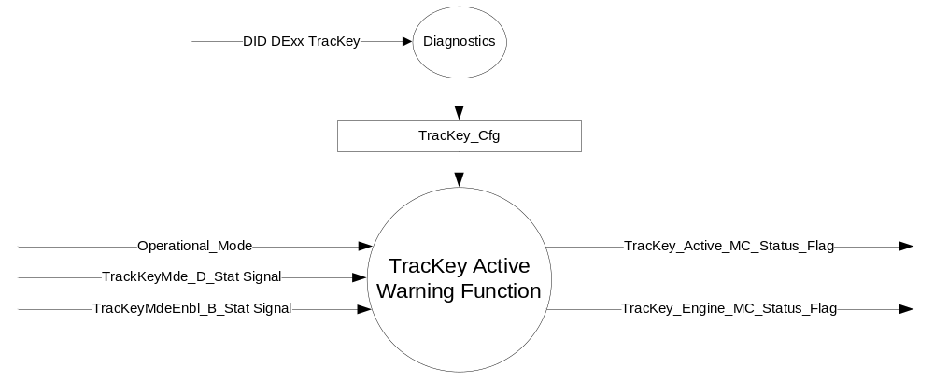

Inputs
      - INTERNAL:
- Operational_Mode

- MUX signals from the CAN bus

- TracKeyMdeEnbl_B_Stat Signal
Signal Name | Size (bits) | Detail | Units | Res. | Offset | State Encoded | Min | Max
TracKeyMdeEnbl_B_Stat | 1 |  | SED | 1 | 0 |  | 0  (0x0) | 1  (0x1)
 |  | Off |  |  |  | 0x0
 |  | On |  |  |  | 0x1

- TracKeyMde_D_Stat Signal
Signal Name | Size (bits) | Detail | Units | Res. | Offset | State Encoded | Min | Max
TracKeyMde_D_Stat | 2 |  | SED | 1 | 0 |  | 0  (0x0) | 3  (0x3)
 |  | ModeNotDetermined |  |  |  | 0x0
 |  | Active |  |  |  | 0x1
 |  | NotActive |  |  |  | 0x2
 |  | NotUsed |  |  |  | 0x3

Outputs
- TracKey_Active_MC_Status_Flag is used to control the Warning displayed in the message center.
- TracKey_Engine_MC_Status_Flag is used to indicate the PCM is using the TracKey calibration.

Function/Performance

Operational Modes

Mode | Differentiating Vehicle Conditions
Sleep Mode | TracKey Warning Text Messages Inactive
Limited Mode | TracKey Warning Text Messages Inactive
Normal Mode | TracKey Warning Text Messages Active/Inactive
Crank Mode | TracKey Warning Text Messages Inactive

Voltage Levels

Refer to the Cluster Features Table located in the Operational Modes and Voltage Range Strategies Section of this SPSS

Human-Machine Interface

Visual

Indicator Graphics / Display Format
Message Center Text Warning Message as defined in section 1.3.5.7 of this document.

Indicator Color Coordinates
Reference section COLOR & ILLUMINATION REQUIREMENTS (GRAPHICS).

Audio

The Message Center Informational Warning Chime is associated with this Warning.

Switch Control Logic

None.

System Accuracy

Within 100 msec of receiving a message that results in a change of state the cluster will update the output flag to the proper state.

Operation: Performance and Functional

Subsystem Algorithm Flowchart / State Diagram

Figure 2 TracKey Configuration Flowchart

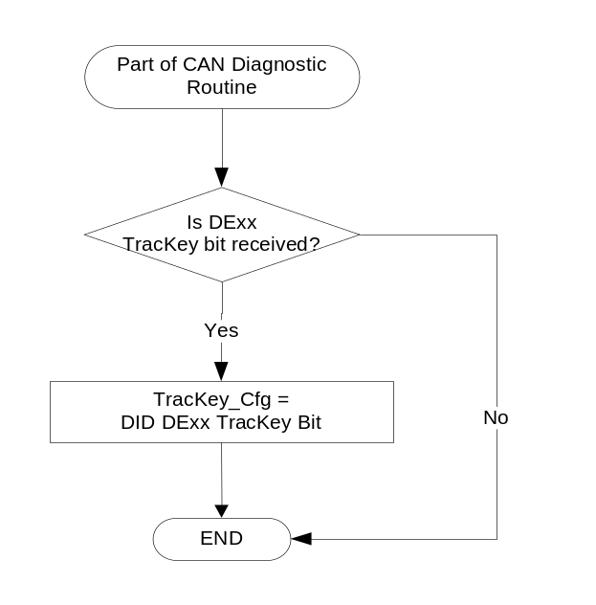

- State Matrix for Warning – TracKey_Active_MC_Status_Flag
Operational_Mode | TracKey_Cfg | TracKeyMde_D_Stat Signal | TracKey_Active_  MC_Status_Flag
Normal | Enabled (0x1) | Active (0x1) | Active
All Other Cases |  |  | Inactive

- State Matrix for Warning – TracKey_Engine_ MC_Status_Flag
Operational_Mode | TracKey_Cfg | TracKeyMdeEnbl_B_Stat Signal | TracKey_Engine_  MC_Status_Flag
Normal | Enabled (0x1) | On (0x1) | Active
All Other Cases |  |  | Inactive

Operation Description (supports algorithm flowchart /state diagram)

- When TracKey_Active_MC_Status_Flag = Active, Warning ID W893 will be Active.
- When TracKey_Engine_MC_Status_Flag = Active, Warning ID W894 will be Active.
- For definition of how the Message Center arbitrates and displays Active warnings, see the Warning / Alert Display Logic Diagram, located in the Message Center – X Display with W Button Interface section of this SPSS (where X and W are appropriate values in this document).

Function Safety Classification (EMC)

Class B

Memory Storage

Parameter Name | Description | Value at  Battery Connect | Value at  Module Wake-up
TracKeyMde_D_Stat Signal | Input from BCM providing status of TracKey | ModeNotDetermined (0x0) | ModeNotDetermined  (0x0)
TracKeyMdeEnbl_B_Stat Signal | Input from PCM | Off (0x0) | Off (0x0)
TracKey_Cfg | State Indicator for feature presence controlled via CAN at EOL at VO plant. Defaulted to DISABLED at supplier manufacturing. | Use Stored Value | Use Stored Value
TracKey_Active_MC_Status_Flag | Used to control the state of the warning to the Message Center arbitrator | Inactive (0x0) | Inactive (0x0)
TracKey_Engine_MC_Status_Flag | Used to control the state of the warning to the Message Center arbitrator | Inactive (0x0) | Inactive (0x0)
Operational_Mode | 4 state indicator for cluster operational mode | Limited | Limited or Normal or Crank

Prove Out

No.

Reconfigurable Telltale

No.

Message Center Msg

Warning Message ID W893 and W894, as defined in the Text Message List section of this SPSS.

Error Handling

The signals will be declared missing as per the Diagnostics section of this SPSS.

DTCs states and history will be determined as per the Diagnostics section of this SPSS.

If TracKey_Cfg = 0x0 (Disabled), the cluster shall never log a missing message DTC due to this feature.

Diagnostics

Self Test

None

Engineering Test Mode

Not Applicable

Part II Performance

Supported Diagnostic Trouble Codes (DTCs)
DTC | Description
C10000 | Lost communication with ECM/PCM
C14000 | Lost Communication With Body Control Module (BCM)

Supported Diagnostic PIDs (Service $22 and $2F)
Number | PID / CommonID Name | PID Type
601C | Track Key Activation Status | Bit Mapped

DID DExx Configuration
Block  Num | Block Description | Byte(s) | Bits | State: Description | "0" | "1" | Default | Comments/ Information
PACKETED BLOCKS
$xx | Option Content (B&A) | * | * | TracKey | Disabled | Enabled | Disabled
*Byte and bit location to be identified in Part II Specification for this cluster

Reference Specification

IS-0001 WARNINGS/INDICATORS/DISPLAYS PROVEOUT
IS-0046 INSTRUMENTATION MATERIAL RESISTANCE TO CLEANING
IS-0052 OPERATING VOLTAGES - FUNCTIONAL/PERFORMANCE
IS-0069 FUNCTIONAL IMPORTANCE CLASS
IS-0324 WINDSHIELD & OTHER REFLECTIONS
IS-0327 WARNING INDICATOR EVALUATION
IS-0379 NORTH AMERICAN WARNINGS AND INDICATORS STRATEGY

IL-0021 CRAFTSMANSHIP - DISPLAYS
IL-0023 CLARITY/LEGIBILITY/READABILITY
IL-0025 INTERIOR ILLUMINATION INTENSITY
IL-0027 VISUAL CONTRAST
IL-0043 OPERATIONAL ENVIRONMENT FUNCTIONALITY
IL-0045 COLOR
IL-0048 ILLUMINATION ACCEPTABILITY

03-0661 PLACEMENT: CONTROL AND DISPLAY LOCATIONS
03-0662 PLACEMENT: LOGICAL GROUPING FUNCTION AND USAGE
03-0664 PLACEMENT: DOWN VISION TO COMPONENTS WITH HIGH VISUAL DEMAND
03-0665 PLACEMENT: EXPECTED LOCATIONS OF CONTROLS AND DISPLAYS VDS
03-0670 INTERIOR VISIBILITY
03-0671 INTERIOR VISIBILITY: REFLECTIONS FROM COMPONENTS & SURFACES
03-0672 INTERIOR VISIBILITY: REFLECTIONS IN DISPLAYS
03-0673 INTERIOR VISIBILITY: VISUAL OBSCURATIONS
03-0674 INTERIOR VISIBILITY: ILLUMINATION CONTROLS / DISPLAYS
03-0675 INTERIOR VISIBILITY: VEILING GLARE
03-0677 INTERIOR VISIBILITY: SUNLIGHT WASHOUT
03-0681 IDENTIFICATION: CHARACTER AND SYMBOL SIZE
03-0682 IDENTIFICATION: LEGIBILITY
03-0685 IDENTIFICATION: SYMBOLS, ABBREV FOR CONTROL
03-0721 LOGIC OF OPERATION: OPERATIONAL STEREOTYPES
03-0722 LOGIC OF OPERATION: INTERPRETATION
03-0723 LOGIC OF OPERATION: USE OF SYSTEMS WITH VISUAL DISPLAYS

Revision History

SPSS Module Revision History

Revision Level | Name | Change Description | Date
1.0 | V. Patel | Initial Release for 2016 S550 (and 2015 service) clusters.  Feature owner:Tom Miller, Jim Cikalo | 06/05/2014
1.1 | V. Patel | Changed the name of TracKeyMdeEnbl_B_Actl signal to TracKeyMdeEnbl_B_Stat throughout the document. The change was made to match the signal name in the CAN database. | 9/9/2014

